EdWest Education Year 12 Physics 2005

Suggested Solutions

Section A
- a) Low pitched sound, ∴long wavelength that approximates door width. ∴ diffraction maximised.
b) Assume L = 1.2 m.
λ = 2 x 1.3 = 2.4 m
∴ v = f x λ
= 65.4 x 2.4
= 157 m s⁻¹
- Assume end of barrel is 10 cm above ground
For y dir’n
V_{y} = 1.5 sin 32º
= 0.79488 m s⁻¹
s = ut + ½ at²
-0.1 = 0.79488t + ½ (-9.81)t²
∴ t = 0.245 s
For x dir’n
s_{x} = u_{x} x t
= (1.5cos32º) x 0.245
= 0.312 m
- Crane A would be more stable as the centre of mass is well within its wide base. Crane B has a much smaller base and its centre of mass would not have to shift far for it to be outside the base and cause the crane to topple.

 Time of flight
✓ Initial velocity
 Net force during flight
 Net acceleration during flight
✓ Final (impact) velocity
✓ Final horizontal displacement
 Final vertical displacement
- When some minerals absorb uv light, their electrons are promoted to higher levels. When these electrons return to the ground state, they often do so via a series of smaller steps that may emit photons of visible light. Therefore by illuminating a fluorescent gem with uv light, it appears to ‘glow’ visible light.
- a) 6th harmonic
b) 6 x ½ λ = 0.75 cm
∴ λ = 0.25 cm
f = v/λ
= 346/0.25
= 138 Hz
- This observation is explained by resonance. Tape recorder plays back at the natural frequency of the tuning fork, ∴stimulating the fork at its natural frequency. ∴causing the tuning fork to vibrate at its natural frequency and make a sound.
- Assume r = 0.2 m
want a_{c} >= g
∴ v²/r >= 9.81 m s⁻¹
∴ v >= 1.40 m s⁻¹
- a) I = P/V
= 80 x 10³/450
= 1.78 x 10³ A
b) n_{p}/n_{s} = V_{p}/V_{s}
= 130 000/450
= 289
ie: 289:1
- Sodium lamp produces a line spectrum only. This is caused by a high potential difference exciting electrons to high levels and upon returning to the ground state, photons of yellow light are emitted.
The candle produces a continuous spectrum with a few lines due to specific elements present in the wax. This is caused by incandescence, where a hot object emits a variety of photons, the energy of which depends on the temperature of the object.
- a) Assume: length = 30 cm
distance between nail and pivot point = 5 cm
Hammer claws are perpendicular to nail
ΣCWM = ΣACM
120 x 0.3 = F x 0.05
∴ F = 7.20 x 10³ N
b) Claws of hammer are perpendicular to nail, maximising the force in the direction of the nail, this will prevent nail from bending and make it easier to remove.
Also pivot point is closer to nail, smaller ‘r’ results in larger ‘F’ (M= rF)
- E = F/A
ΔL/L
2.10 x 10¹¹ = 120 x 10³/(π x 0.05²)
ΔL/0.33
∴ ΔL = 2.40 x 10⁻³ m (2.40 mm)
- eg: Arrange bars as below:
This technique will successfully identify the magnetised bar.
N
N
S
S
Limited attraction.
Strong attraction.
- a) DC. Would produce a constant magnetic field in the coil, to apply a torque in a constant direction. AC would simply cause the needle to oscillate.
b) When a current is present in the coil, a magnetic field is induced and this interacts with the external magnetic field. This causes the armature and pointer to turn and try to align the two fields against the force of the spring. The larger the current, the more movement is produced and this movement can be calibrated to measure the current flowing.
- Blue. Photons blue light are more energetic (E = hf) as they are of a higher frequency than photons of red light

Section B
- a) 2 T cos 30º = 225 x 9.81
∴ T = 1 270 N
b) Take moments about pivot:
ΣCM = ΣACM
2210 x 5.5 x sin70º + 1230 x 2.75 x sin 70º = F_{R} x 2.5 x sin30º
∴ ^{F}_{R} = 1.16 x 10⁴ N
c) Horizontal distance from CoM of beam to rear wheels of crane:
= 4.50 – (5.5/2 x cos 20⁰)
= 1.92 m
Taking moments about rear wheels of crane:
ΣCM = ΣACM
(L x 9.81 x 4.5) + (125 x 9.81 x 1.92) = 5.6 x 10³ x 9.81 x (2.5 – 0.75)
∴ L = 2.12 x 10³ kg
d)
* Raise boom. This will decrease horizontal distance from rear wheels to load, ∴ decrease the CW moment caused by the load.
* Shorten the boom. This will decrease horizontal distance from rear wheels to load, ∴ decrease the CW moment caused by the load.
* Install ‘outriggers’ at rear of crane. This will shift the pivot point closer to the load and further from the counter-mass. ∴ reduce moment caused by load and increase moment caused by mass of crane.
e) Breaking stress = 11.0 x 10⁸ Pa
σ = F/A
11.0 x 10⁸ = 2.12 x 10³ x 9.81/A
∴ A = 1.89 x 10⁻⁵ m
∴ πr² = 1.89 x 10⁻⁵ m
∴ r = 2.45 x 10⁻³ m
∴ d = 4.90 x 10⁻³ m
f) (c): No difference as both CW and ACM would both be less
(e): Thinner cable possible as less stress due to smaller weight.
- a) i)
15º
T
W
F_{net}
ii) ΣF_{y} = 0
mg = 0.15 x g x sin 15º
= 3.88 x 10⁻² kg
iii) Tcos 15º = mv²/r
0.15 x 9.81 x cos 15º = 3.88 x 10⁻² x v²/0.33cos 15º
∴ v = 3.42 m s⁻¹
iv) Shorter. Tension would be greater due to increased gravity. As T α 1/r (T=mv²/r), r becomes smaller as T becomes greater.
b) i) E = hf
= 6.63 x 10⁻³⁴ x 3.00 x 10⁸/514 x 10⁻⁹
= 3.87 x 10⁻¹⁹ J
ii) Power of 514 nm photons emitted = 99.9/100 x 1.33 = 1.3287 W
ie: 1.3287 Joules per second.
∴ No of photons = 1.3287/3.87 x 10⁻¹⁹
= 3.43 x 10¹⁸
iii) 3.87 x 10⁻¹⁹ J = 2.42 eV
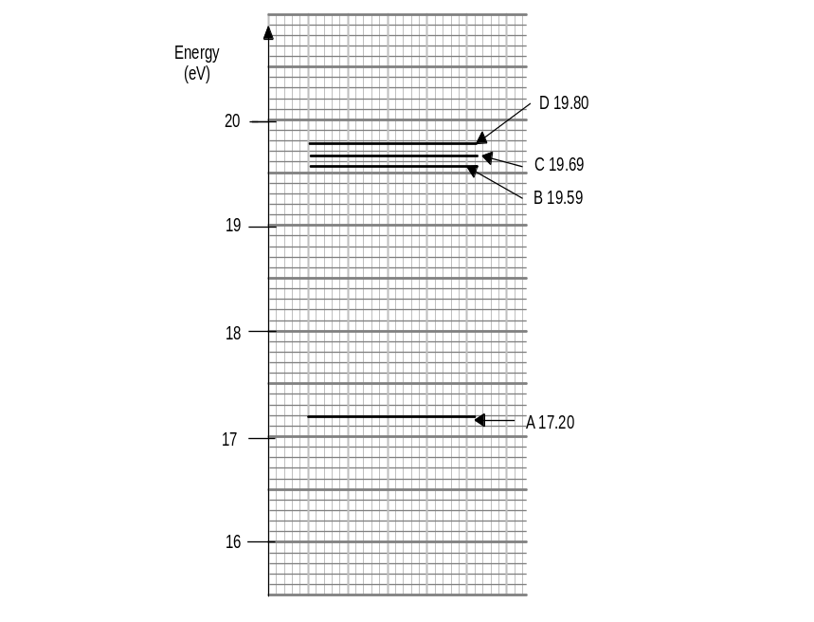

- a) i) D
ii) BiL = ma
a = 4.0 x 10⁻² x 16.0 x 4.0 x 10⁻²/55 x 10⁻³
= 0.465 m s⁻²
iii) Friction between wheels and rail
Movement of axle induces a current, the field of which opposes the direction of motion – Lenz’s law.
b) i) Vertical
ii) B_{v} = 2.0 x 10⁻⁴ x sin60º
= 1.73 x 10⁻⁴ T
iii) emf = 1.73 x 10⁻⁴ x 10 x 200
= 0.346 V
iv) No. Any wiring used to make a complete circuit will also cut flux and induce an emf. ∴ no net emf.
v)
- a) i) Destructive interference. Sound from the two speakers is arriving ½ λ out of phase.
ii)
λ/2 = d₂ – d₁
= √(1.85² + 8²) - √(1.15² + 8²)
∴ λ = 0.25784 m
∴ f = 346/0.25784
= 1340 Hz
3.0 m
8.0 m
d₁
d₂
1.15 m
1.85 m
iii) Constant tone as it is an antinodal line. Would get louder as she approached the speakers.
iv) She would have experienced destructive interference originally (quiet) and constructive interference (loud) when she moved her head.
- a) i) g = GM/r²
= 6.67 x 10⁻¹¹ x 1.35 x 10²³/(2575 x 10³)²
= 1.36 m s⁻²
ii) GM_{s}M_{T}/r² = M_{T}v²/r
∴ M_{s} = v²r/G
= (5.57 x 10³)² x 1221850 x 10³/6.67 x 10⁻¹¹
= 5.70 x 10²⁶ kg
b) Want period of 15.95 x 14 x 60 x 60 = 1.378 x 10⁶ s
r³ = GM_{T}T²/4π²
∴ r = 7.57 x 10⁷ m
∴ altitude = 7.57 x 10⁷ – 2.575 x 10⁶
= 7.31 x 10⁷m
c)
i) Will assume a_{c} = g (ie: 250 m altitude would have negligible effect on gravity strength).
v²/r = g
v² = 1.36 x 2.575 x 10⁶
∴ v = 1.87 x 10³ m s⁻¹
ii) No. Kit would be moving so fast that it would be destroyed on impact.
iii) If she was travelling any slower at that altitude, she would need to use her thrusters to maintain altitude and not crash. This would use fuel.
iv) No. Air resistance would cause ship to decelerate and ultimately lose altitude and crash, ∴ such a low orbit would not be possible. Also at such a speed, the spaceship may ‘burn up’.
- a) i) 41º. As plate is fully immersed, the whole time, there is no change in flux, ∴ no induced emf and no retarding force.
ii) Would not swing as high due to the eddy currents induced by the magnetic field reversing. These eddy currents have a field that oppose the external field (Lenz’s law) and retard the motion. Therefore it would make an angle greater than 41º with the horizontal.
iii) (i): no change
(ii): less retardation as smaller eddy currents induced. Would swing higher.
b) i) 1.0 x 10⁻¹² W m⁻²
ii) Assume: Sound travels spherically and no sound energy is lost.
P = I x A
= 10⁻¹² x 4π(10)²
= 1.26 x 10⁻⁹ W
iii) I = P/A
= 1.26 x 10⁻⁹/4π(0.1)²
= 1.00 x 10⁻⁸ W m⁻²
∴ L = 10 log (I/10⁻¹²)
= 10 log (10⁻⁸/10⁻¹²)
= 4.00 x 10¹ dB
iv) No of mozzies = 10⁻⁸/10⁻¹²
= 1.00 x 10⁴ (10 000 - ouch!)

Section C

Passage 1
- No. It is not fluorescence as the web is reflecting the uv light not absorbing it and re-emitting it as visible light. (Although possibly high frequency uv is absorbed and lower frequency uv is re-emitted which is visible to insects but not to us.)
- The radial threads don’t have the sticky watery glue which causes the threads to bunch up and allow the ‘give’ of the spiral threads.
- Radial threads are responsible for transmitting the vibrations of captured insects to the spider. The stiff threads are best for this purpose as the stiffer the material, the faster the vibrations are transferred. This is illustrated by the difference in the speed of sound between solids and liquids.

Property | Type of thread (R or S)
Made sticky with a watery glue | S
Stiffest | R
Most elastic | S
Lowest Young’s Modulus value | S
Best at transmitting vibrations | R

- stress/strain = 1.1 x 10^{9/}/0.19 = 5.79 x 10⁹ Pa. This value is less that the Young’s modulus value, indicating that the thread was behaving plastically.
Passage 2
- The current needs to constantly reverse direction so that the particle is always accelerated as it passes between the dees. If it was DC, it would accelerate in one direction and decelerate in the other.
- Because it is gaining velocity each time it passes between the dees. F_{c}=mv²/r. ∴ v² α r. ie: the radius of curvature increases with increased velocity.

- In a synchrotron the magnetic field increases in strength so that the centripetal force applied is strong enough to keep the particles in a constant radius circle, even though they are constantly speeding up. In a cyclotron he radius of curvature increases until the particle exits.
- Out of the page
- Bvq = mv²/r
1.5 x v x 1.6 x 10⁻¹⁹ = 3.34 x 10⁻²⁷ x v²/0.25
∴ v = 1.79 x 10⁷ m s⁻¹
- a) T = 1/f
= 1/10.6 x 10⁶
= 9.43 x 10⁻⁸ s
b) v = 2πr/T
= 2π(0.24)/9.43 x 10⁻⁸
= 1.59 x 10⁷ m s⁻¹
Bvq = mv²/r
B = mv/rq
= 1.67 x 10⁻²⁷ x 1.59 x 10⁷/0.24 x 1.6 x 10⁻¹⁹
= 0.695 T
c) B would have been smaller as the radius of curvature would be greater. B α 1/r
END OF SOLUTIONS

